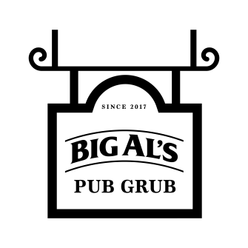

**Stone Baked Italian Pizza Twist** £4.99

Margherita

Pepperoni

**BURGERS**

**Gourmet Wood Smoked Dog**  £3.99

In white roll topped with ketchup & American

mustard and diced red onion

**BBQ Pork Rib** £4.99

Served in a soft white roll with BBQ sauce and

diced red onion

**………………………………………..**

**CHICKEN**

**………………………………………..**

**6 Mesquite Wings** £4.99

With mayo & Chipotle dips

and salad garnish

**12 Sharing Wings** £9.49

With mayo & Chipotle dips

and salad garnish

**PIZZA & MORE**

**Chicken Burger** £4.49

Chicken fillet in a gourmet burger

bun with mayo and iceberg lettuce

**Cheesy Chicken Burger**  £4.99

Chicken fillet in a gourmet burger bun with

mayo and iceberg lettuce topped with cheddar cheese

**Bacon & Cheese Chicken Burger** £5.49

Chicken fillet in a gourmet burger bun with mayo

and iceberg lettuce topped with cheddar cheese

and bacon

**Classic Quarter Pounder** £4.49

Served in a gourmet burger bun with iceberg lettuce, red onion and burger sauce

**Cheese Burger Quarter Pounder** £4.99

Served in a gourmet burger bun with iceberg lettuce, red onion and burger sauce topped with cheddar cheese

**The Cheese & Bacon Quarter Pounder** £5.49

Served in a gourmet burger bun with iceberg lettuce, red onion and burger sauce topped with cheddar cheese and bacon

**Double Classic** £5.49

Two quarter pound burgers served in a gourmet burger bun with iceberg lettuce, red onion and burger sauce

**Double Cheese Burger**  £5.99

Two quarter pound burgers served in a gourmet burger bun with iceberg lettuce, red onion & burger sauce topped with cheddar cheese

**The Ultimate Burger** £6.49

Two quarter pound burgers served in a gourmet burger bun with iceberg lettuce, red onion and burger sauce topped with cheddar cheese and bacon

Eat, **DRINK AND ENJOY**

Offers are subject to availability and can be withdrawn at anytime

Ask at the bar for allergen information if needed

Prices include VAT where applicable